ГУАП

КАФЕДРА № 43

ОТЧЕТ   
ЗАЩИЩЕН С ОЦЕНКОЙ

ПРЕПОДАВАТЕЛЬ

|  |  |  |  |  |
| --- | --- | --- | --- | --- |
| Старший преподаватель |  |  |  | Н.В Путилова |
| должность, уч. степень, звание |  | подпись, дата |  | инициалы, фамилия |

|  |
| --- |
| ОТЧЕТ О ЛАБОРАТОРНОЙ РАБОТЕ №7  Разработка SQL запросов: запросы с подзапросами |
| **по дисциплине: Проектирование баз данных** |
|  |
|  |

РАБОТУ ВЫПОЛНИЛ

|  |  |  |  |  |  |
| --- | --- | --- | --- | --- | --- |
| СТУДЕНТ ГР. | 4134к |  |  |  | Костяков Н.А. |
|  |  |  | подпись, дата |  | инициалы, фамилия |

Санкт-Петербург

2023

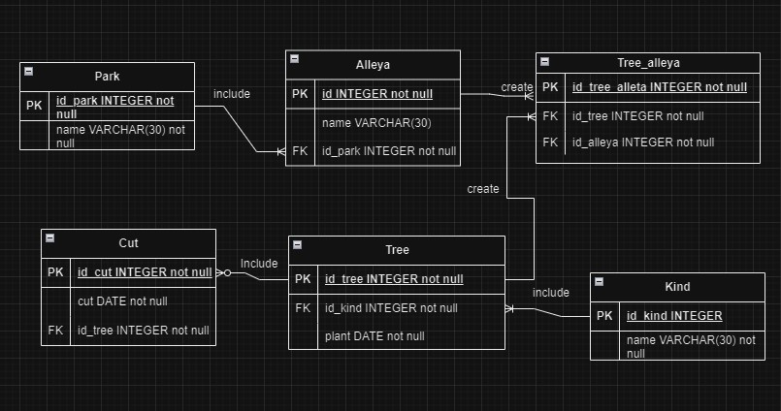

**Процедура вставки с пополнением**

create OR REPLACE procedure ins_tree(ins_kind varchar(128), ins_plant date, ins_alleya varchar(128), ins_park varchar(128))

LANGUAGE plpgsql

AS $$

BEGIN declare id_all_new int;

declare id_park_new int;

begin

IF exists (select * from park where park.name=ins_park)

THEN select park.id_park into id_park_new from park where park.name = ins_park;

else begin

select id_park_new = (nullif(max(park.id_park), 0)+1) from park ;

insert into park(id_park, name_park) values (id_park_new, ins_park);

end;

end if;

begin

IF exists(select * from alleya where alleya.name = ins_alleya)

THEN select alleya.id_alleya into id_all_new from alleya where alleya.name = ins_alleya;

else begin

select id_all_new = (nullif(max(alleya.id_alleya), 0)+1) from alleya ;

insert into alleya(id_alleya, name_alleya, id_park) values (id_alleya_new, ins_alleya, is_park_new);

END;

end if;

declare id_kind_new int;

begin

if exists(select * from kind where kind.name = ins_kind)

then select kind.id_kind into id_kind_new from kind where kind.name = ins_kind;

else begin

select id_kind_new = (nullif(max(kind.id_kind), 0)+1) from kind ;

insert into kind(id_kind, name) values (id_kind_new, ins_kind);

end;

end if;

declare id_t_a int = (nullif(max(tree_alleya.id_tree_alleya), 0)+1) from tree_alleya;

declare id_tree_new int = (nullif(max(tree.id_tree), 0)+1) from tree;

begin

insert into tree values (id_tree_new, id_kind_new, ins_plant);

insert into tree_alleya(id_tree_alleya ,id_tree, id_alleya) values (id_t_a,id_tree_new, id_all_new);

end;

end;

end;

end;

end

$$;

call ins_tree ( 'Дуб'::varchar(128), '2023-11-25'::date, 'Быстрая'::varchar(128), 'Космический'::varchar(128));

Слева – было. справа - стало

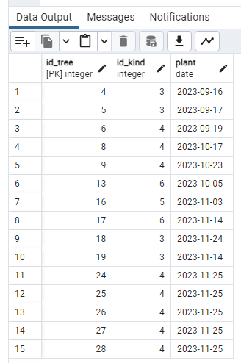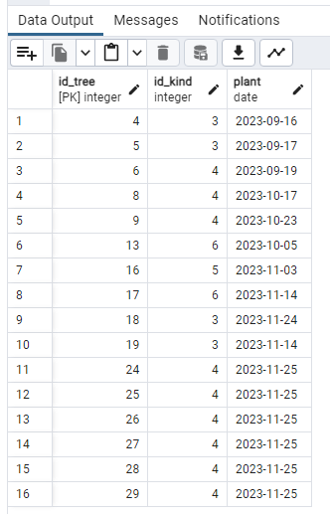

--удаление с очисткой справочника

create or replace procedure del_tree(id_t int)

language plpgsql

as $$

begin

begin

delete from tree_alleya where id_t = tree_alleya.id_tree;

end;

declare id_all_new int = (select id_alleya from tree_alleya where id_tree = id_t);

begin

if not exists (select * from tree_alleya where id_alleya=id_all_new)

then delete from alleya where id_alleya = id_all_new;

end if;

delete from tree where id_tree = id_t;

end;

end

$$;

-- call del_tree(10);

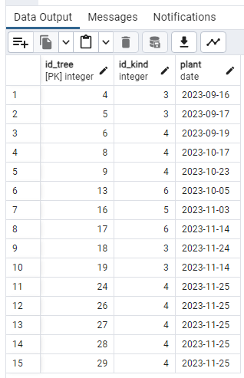

--Каскадное удаление

create or replace procedure del_kind_cascade(id_to_del int)

language plpgsql

as $$

begin

delete from tree_alleya where tree_alleya.id_tree in

(select tree.id_tree from tree where id_kind = id_to_del);

delete from cut where cut.id_tree in

(select tree.id_tree from tree where tree.id_kind=id_to_del);

delete from tree where tree.id_kind = id_to_del;

delete from kind where kind.id_kind = id_to_del;

end;

$$

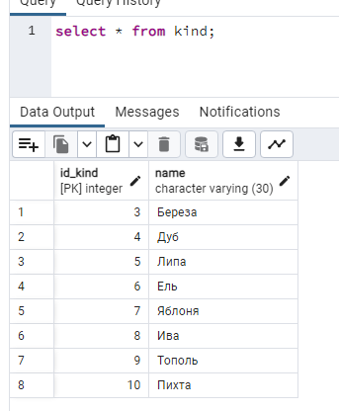 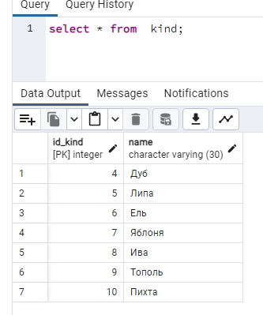

--Процедура вычисления и возврат значения агрегатной функции

create or replace function count_trees() returns integer

language plpgsql

as $$

begin

return nullif(count(id_tree), 0) from tree;

end

$$;

select count_trees();

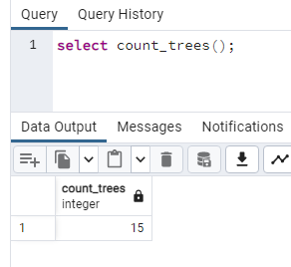

--Формирование статистики во временной таблице

create or replace function stats()

returns table (id_park integer, name_park varchar(128),

alleya_cnt integer, tree_cnt integer,

kind_cnt integer)

language plpgsql

as $$

begin

CREATE TEMPORARY TABLE stat(

id_park integer, name_park varchar(128),

alleya_cnt integer, tree_cnt integer,

kind_cnt integer

);

insert into stat(id_park, name_park, alleya_cnt, tree_cnt, kind_cnt)

select park.id_park,

park.name,

count(DISTINCT alleya.name),

count( tree_alleya.id_tree ),

count(DISTINCT kind.name)

FROM park

join alleya on alleya.id_park = park.id_park

join tree_alleya on tree_alleya.id_alleya = alleya.id_alleya

join tree on tree.id_tree = tree_alleya.id_tree

join kind on kind.id_kind = tree.id_kind

GROUP BY park.id_park;

return query select stat.id_park, stat.name_park

,stat.alleya_cnt , stat.tree_cnt, stat.kind_cnt FROM stat;

drop table stat;

end

$$;

select * from stats();

